5 Questions To Ask Before Choosing An Attendance System
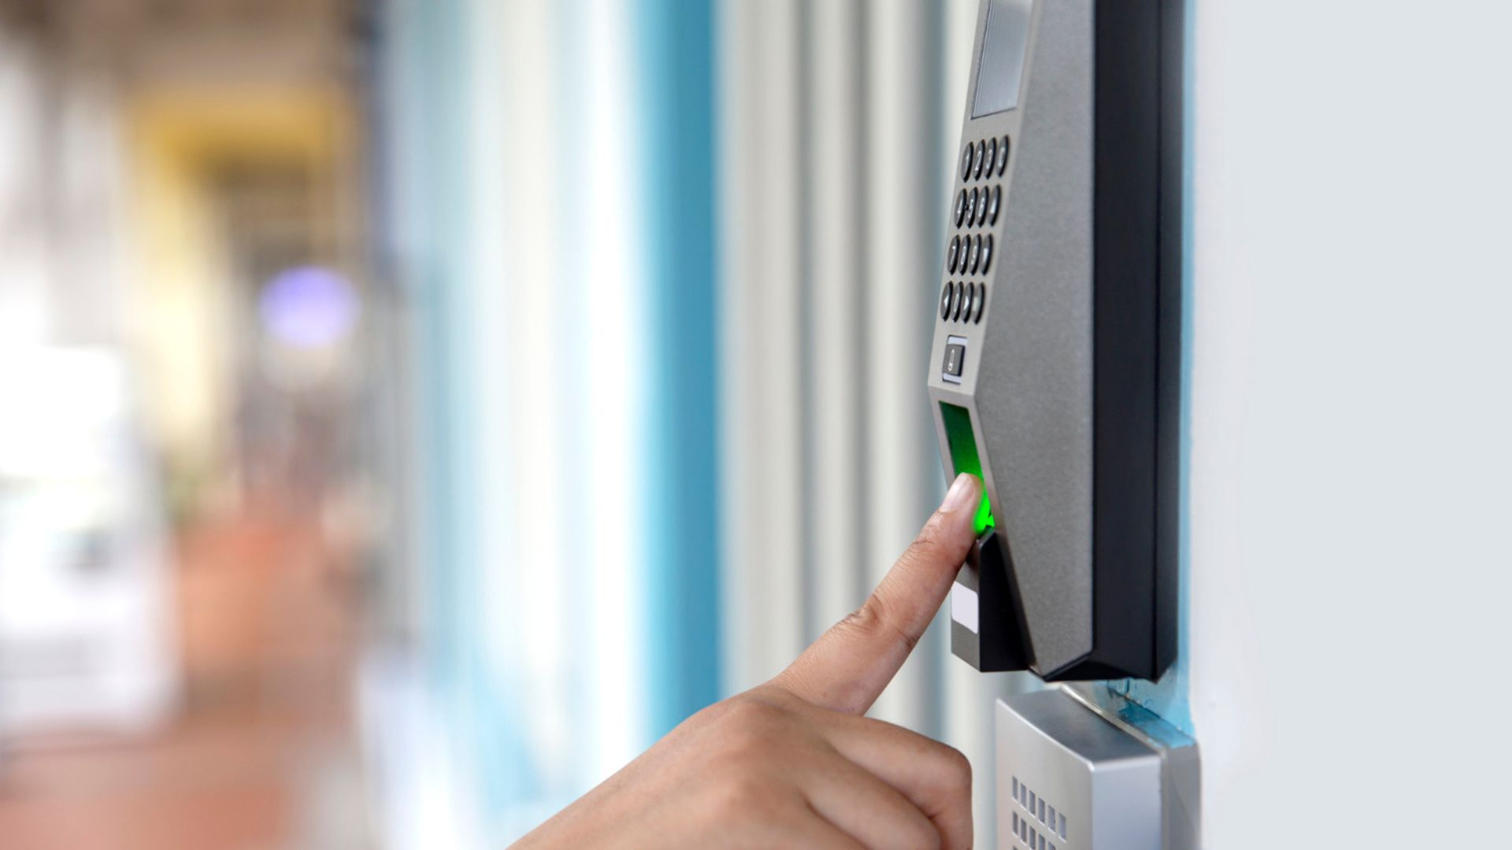
The right choice saves time, prevents errors, and builds trust within your organisation. The wrong choice can lead to endless headaches, hidden costs, and frustrated employees.
In most organisations, the attendance system is a very crucial, but often overlooked task. You don’t notice it when it works, but the moment it fails, everything gets messy. From payroll to compliance and security, a reliable attendance system underpins day-to-day operations.
For purchase managers and decision-makers, however, selecting the right system for your workplace is rarely straightforward. The market is full of options that promise thousands of benefits such as accuracy, integration, and convenience, but not all of them hold up in the real world. That’s why asking the right questions before signing a purchase order is critical.
Here are five key questions that can help you separate marketing gloss from real value:

Q1. How Reliable Is the System in Real-World Conditions?
On paper, most attendance systems look impressive. But the real test is how they perform in actual environments like hot & sweaty factories, dusty schools, humid warehouses, or high-footfall corporate offices. Look for the following while evaluating options:
- Device durability: Fingerprint sensors, for example, may struggle in dusty or high-contact areas, while facial recognition systems need to cope with lighting variations.
- Connectivity and uptime: Can the device work offline and sync later? Does it fail gracefully when the internet drops, or does the entire process stall?
- Scalability: If your organisation grows from 200 employees to 2,000, will the system keep up without major upgrades?
An attendance system that isn’t robust under local conditions may end up costing more in downtime and workarounds than its initial purchase price.

Q2. What Integration Options Are Available?
Attendance data doesn’t live in isolation. It directly feeds into payroll, HR management, compliance reports, and in some industries, even security audits.
When evaluating systems, check:
- HRMS & Payroll Integration: Can the system automatically push data into your HR or payroll software? This saves admin teams hours of manual work and reduces errors.
- ERP/Custom System Compatibility: If you’re a large enterprise with unique systems, flexibility in APIs and integration options becomes critical.
- Cloud vs. On-Premise: Is there a choice depending on your IT policies? Some organisations prefer cloud solutions for ease, while others need on-premise data-storage options for tighter control.
The more seamless the integration, the more value you extract from your investment. A standalone device that doesn’t communicate efficiently with the rest of your tech stack will quickly feel outdated.

Q3. How Secure Is the Data Handling?
Attendance systems, especially biometric ones, deal with highly sensitive personal data. A breach isn’t just a tech failure; it’s a compliance risk and a trust issue.
When assessing solutions, ask:
- Is biometric data encrypted? Both at rest and in transit, encryption is non-negotiable.
- Where is the data stored? Locally, on a secure server, or on the cloud? If on the cloud, which region, and does it comply with local data laws?
- Access controls and logs: Who can view, edit, or export data? Is there an audit trail for accountability?
In India, regulations around data privacy are tightening, and global best practices (like GDPR) are influencing expectations. For government institutions and corporates alike, data security should be one of the first checkboxes to tick.


Q4. What’s the True Cost of Ownership?
Price tags can be misleading. Many organisations fall into the trap of comparing only upfront device costs, without considering the long-term expenses.
A proper cost evaluation should include:
- Hardware durability: Devices that need frequent replacements quickly erode savings.
- Software licenses and renewals: Some vendors charge annually for continued use of their software or cloud.
- Maintenance and servicing: Are spare parts readily available? How expensive are they?
- Downtime costs: If the system fails for a week, what’s the impact on payroll and productivity?
The cheapest option upfront can turn out to be the most expensive in the long run. A holistic cost comparison gives a clearer picture of true value.

Q5. What Kind of After-Sales Support Will You Receive?
No matter how advanced a system is, problems will arise, whether it’s a software glitch, device malfunction, or user training requirement. This is where after-sales support makes or breaks the experience.
Things to look for:
- Response time: Does the vendor offer quick assistance or do you wait weeks for a service call?
- Local presence: Is there on-ground support in your region, or are you dependent on remote troubleshooting?
- Training and onboarding: Do they provide resources to train your staff, or leave it to you to figure out?
Good after-sales service isn’t a “bonus”, it’s a critical factor in ensuring your system continues to deliver value for years.

Making Your Decision
An attendance system is more than a device at your office entrance, it’s the backbone for payroll, compliance, and operational efficiency. The right choice saves time, prevents errors, and builds trust within your organisation. The wrong choice can lead to endless headaches, hidden costs, and frustrated employees.
By asking these five questions — reliability, integration, security, cost of ownership, and after-sales support — you equip yourself to make an informed, long-term decision.
At Access Computech, we’ve seen first-hand how these factors play out in deployments ranging from corporate offices to government schools. That’s why our focus has always been on building systems that are durable, integrable, secure, and backed by responsive support.
Because when it comes to attendance, the best system is the one you never have to think about. It just works.

